- We think 2026 will be another challenging year for the UK economy – our GDP growth forecast of 1% is at the bottom of the consensus. Four themes will be key to the outlook, in our view.
- Fiscal and political risks will remain elevated. We expect markets will increasingly question the fiscal credibility of the Budget and the survival of the Labour leadership. A slow burn of a steepening yield curve and weaker sterling could morph into a more serious confidence crisis.
- The UK lacks a sustainable growth driver. Government spending has played an outsized role in GDP growth in recent years and will do so again in 2026. Prospects for the private sector remain poor. Consumers face a sharp slowdown in real income growth in 2026, while a combination of weak profitability and low confidence will restrain business investment.
- Weak growth and sticky inflation will continue to divide the Monetary Policy Committee. Inflation should cool next year due to lower contributions from food and energy, plus slowing services inflation. But it will likely remain well above target. Alongside weak growth, this will stop the MPC from shifting decisively in one direction or the other. On balance, we expect Bank Rate to be cut to 3.25% by the end of 2026.
- Another year of pain for the labour market. Strong public sector job creation has mitigated the impact of falling private sector headcount, but the boost from the public sector will likely start to fade. Given weak private sector demand, we expect the jobless rate will rise further.
Assuming no historical data revisions, UK GDP growth in 2025 will be around 1.4% – a respectable performance that's only likely to be bettered by the US and Canada of the G7. In our view, however, the headline figure flatters the health of the UK economy; we see a much weaker underlying picture. With no sign of a sustainable growth driver emerging and scant evidence that the government has tackled the UK's long-running structural problems, we expect growth to remain sluggish. In fact, our forecast for GDP growth in 2026 of around 1.0% is at the bottom of the consensus (Chart 1).
Chart 1: We are gloomier than most on the UK's near-term growth prospects
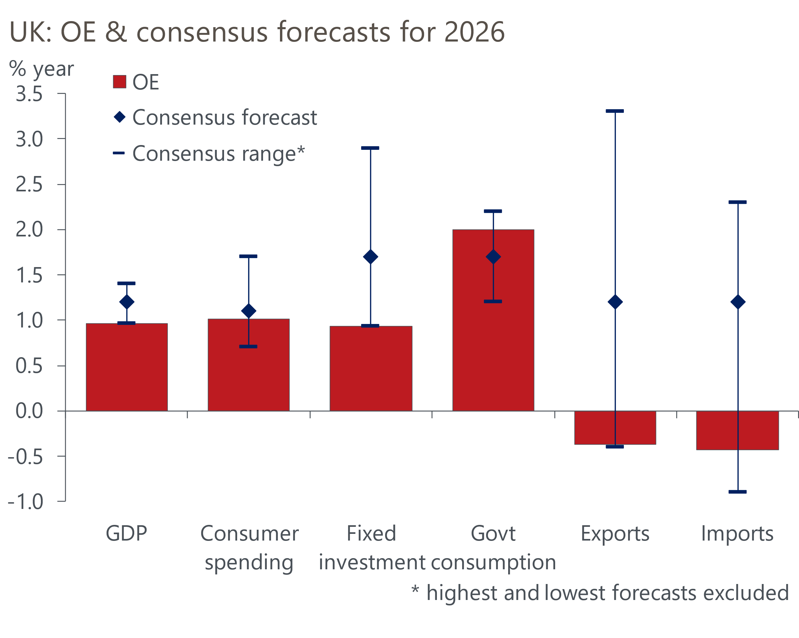
Sources: Oxford Economics, HM Treasury Forecasts for the UK economy, November 2025

Theme 1: Fiscal and political risks will remain elevated
Though initial market reaction to the November Budget was favourable, we were critical of the government's approach. The package lacked a coherent strategy, offering little to promote growth and relying heavily on measures that won't be implemented until well into the future to reduce borrowing. Instead, it appeared more aimed at trying to quell discontent within the governing Labour party, although subsequent media stories suggest it may even have failed that aim.
We expect markets will look increasingly critically at the package. For starters, it's hard to believe the government will stick to its planned large, tax-heavy consolidation in 2029-2030, the year of the next election, particularly as the target year for the fiscal rules will be moving out again at that time. Also, around a quarter of the tightening is due to come from unspecified "efficiency savings".
What's more, the Office for Budget Responsibility's growth forecasts are up with the most optimistic independent forecaster. So in our view, the apparent extra headroom built by the Chancellor in the Budget looks largely illusory.
Meanwhile, the UK's debt dynamics remain very poor. We forecast average nominal GDP growth will be lower than the effective interest rate the UK government will pay on its debt over the next five years. Of the advanced economies, only Italy is in a worse position (Chart 2). History suggests revenue-based consolidations have a higher risk of failure, and the decision to try to generate large amounts from a variety of smaller revenue streams increases that risk. So it looks likely that further tightening will be required at some point, perhaps as soon as the next Budget in autumn 2026.
Chart 2: The UK's debt dynamics are very poor, with only Italy in a worse position
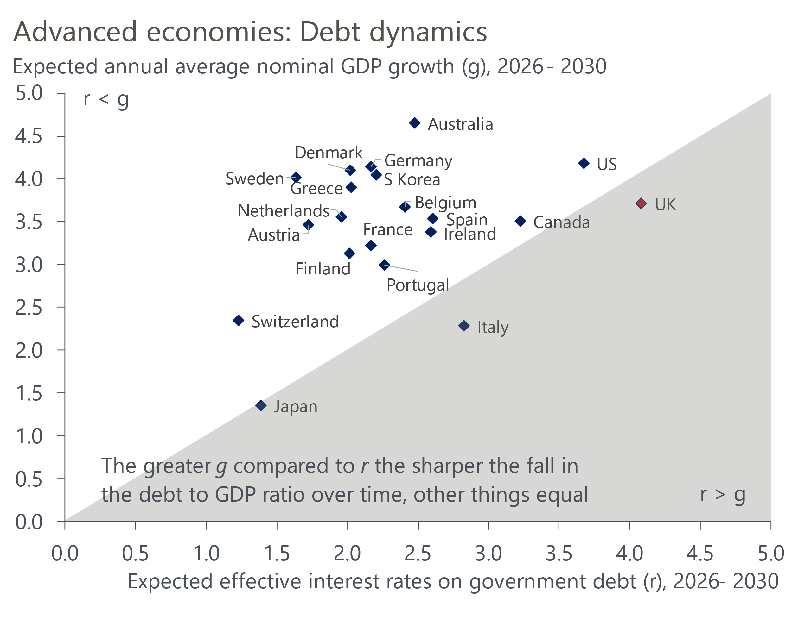
Source: Oxford Economics
The political backdrop also looks very challenging for the Labour government. The spending choices – more generous welfare spending in the near-term and no tangible spending cuts later on – give the impression the government either lacks the will or has not accumulated enough political capital to rein in spending. The party is well behind in all opinion polls, the personal approval rating of Prime Minister Keir Starmer is historically low, and Chancellor Rachel Reeves is also unpopular. There's very little chance of a change of government – Labour has a huge majority and no incentive to call an early election. But it's quite possible that the next political crisis will trigger a change in leadership of the government.
We think a gradual loss of confidence in the UK's fiscal approach will manifest itself in a slow burn of a steepening yield curve and weaker sterling, but that the government will find a way to muddle through. Still, that opens the door to the risk of a more sudden loss of faith, particularly if a change of leadership triggers a lurch to the left. So the downside scenario – including GDP falling 0.6ppts below our baseline forecast by the end of 2027 – that we outlined recently remains a live risk.

Theme 2: The UK lacks a sustainable growth driver
Regarding the growth outlook, it's important to note that the UK's sluggish performance of the past three years would have been significantly worse were it not for the very strong contribution from the government. Of the 2.5% increase in GDP between Q4 2022 and Q3 2025, more than 2ppts came from government consumption and investment (Chart 3). Given that the public sector accounts for just a quarter of the economy, the reliance on the state as the prime growth driver is striking. For 2026, we forecast the public sector will contribute around 0.7ppts to GDP growth.
Chart 3: Since 2022, GDP growth has been heavily reliant on the public sector
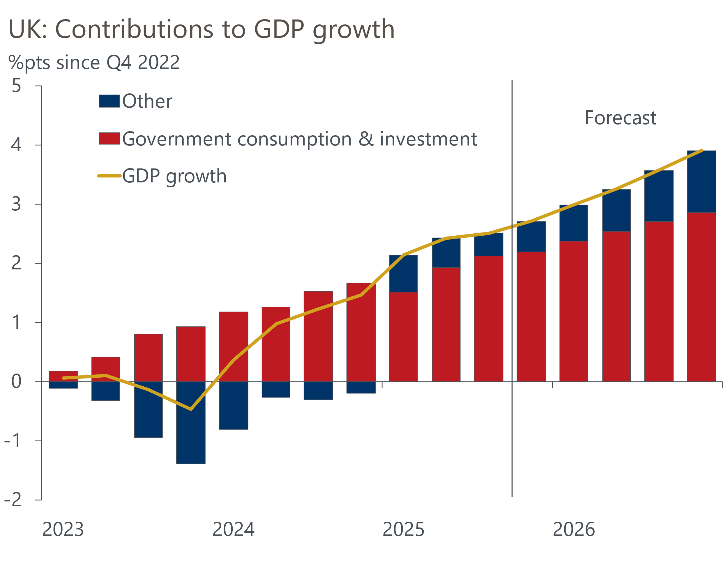
Sources: Oxford Economics, Haver Analytics
On the other side, we see few reasons to be optimistic about private sector demand.
Although consumers have enjoyed a strong recovery in their spending power since the energy crisis began to ease, they have behaved very cautiously, saving a high proportion of their income and showing weak demand for credit. What's more, the momentum behind real income growth has already begun to slow, and we expect this to continue in 2026.
As the labour market loosens, pay growth is slowing, and surveys suggest the new year pay round will result in lower settlements than last year. So, while we expect inflation to cool, real wage growth is likely to be much softer in 2026 than it has been in recent years.
Policy settings will add to the drag on income growth. On the fiscal side, the ongoing freeze in most allowances and thresholds will ensure that income tax and national insurance payments continue to rise strongly. On the monetary side, though we expect further cuts to Bank Rate, the impact will be more than offset by mortgagors continuing to refinance cheap fixed-rate deals taken out before mid-2022. And with returns on savings falling as the policy rate is cut, we think net interest income will increasingly weigh on household incomes in the near term.
Consumers may have scope to mitigate the impact of weaker income growth by saving less. Sentiment surveys suggest that consumers have become more confident about their personal financial situation and the climate for making major purchases over the past couple of years. But while this may result in a period where growth in consumer spending outstrips improvements in spending power, we still expect consumer spending growth next year to be limited to around 1%, as it has been in recent years.
The outlook for companies sector is similarly subdued. Though cuts to Bank Rate feed through to the corporate sector more quickly, given that most debt is at variable rates or short fixes, the financial health of companies remains poor. As a share of gross value added, corporate profits were at an 18-year low in Q3 2025, with firms having battled a series of cost pressures including high energy costs, sustained strong pay growth, and more recently the increase in employers' NICs. Though the peak impact from these factors is now behind us and we expect profitability to improve, progress is likely to be slow. This will limit the availability of internal funding for investment.
At the same time, most measures of business confidence are at low levels. This reflects a combination of domestic factors, such as the ever-present speculation about tax rises, and the impact of trade policy uncertainty. The combination of scarce funding and fragile sentiment means we expect business investment to remain broadly flat over the next year.
We're similarly gloomy about prospects for UK exports. This is an area where the UK has struggled in recent years, particularly since its departure from the EU. While we're more optimistic than most about prospects for the US – the UK's most important export destination – in 2026, we are relatively pessimistic about what this means for US imports. So the impact on UK firms will be limited. We are fairly downbeat about prospects for other key export markets, most notably the Eurozone. And the competitiveness of UK goods exports continues to be blunted by high energy prices, particularly compared with the US, and Chinese overcapacity.
Furthermore, the UK is unlikely to enjoy the type of boost from AI that is currently sweeping across the US, China, and some other Asian economies. There's no evidence of the UK seeing a big increase in digital tech investment spending, as has happened in the US, nor is the UK a major player in the sectors that manufacture the equipment.
Overall, our 2026 forecasts for all the main private sector growth drivers are below the consensus – and in some cases towards the bottom of the forecast range (Chart 1).

Theme 3: Weak growth and sticky inflation will continue to divide the Monetary Policy Committee
A key uncertainty around the consumer outlook is how sticky inflation will prove to be. The CPI rate reached 3.8% in September, almost double the target, and though it has subsequently started to fall, there's significant uncertainty around the pace of decline in 2026. How this plays out will play a crucial role in both the consumer outlook and the scope for the Bank of England's Monetary Policy Committee to cut interest rates.
The pickup in inflation in 2025 was due to a combination of stronger contributions from the more erratic categories, most notably food and energy, and sticky services inflation. We expect the contributions of food and energy together to be around 0.3ppts-0.4ppts lower in 2026. This reflects lower wholesale costs, the lagged pass through of a stronger pound, and, in the case of energy, the government removing some levies from domestic bills. But there will need to be a material slowdown in services inflation if the headline rate is to move much closer to target.
Given that wages form a large part of firms' cost base in the services sector, the recent slowdown in pay growth bodes well for inflation. Over the past six months, several MPC members have expressed concerns that cooling pay growth hasn't translated into weaker inflation pressures. We think this is partly because they have under estimated the degree to which the April 2025 increases in employers NICs and the national living wage had fed through to services prices. It also likely reflects the impact of large increases in regulated and indexed prices.
The impact of increases in national insurance contributions and the national living wage will fade this year. But indexed prices will rise sharply again in response to elevated inflation in 2025 (Chart 4). So while services inflation should steadily cool, we expect CPI inflation to remain well above the 2% target throughout 2026.
Chart 4: We expect inflation to cool gradually but to remain well above 2% throughout 2026
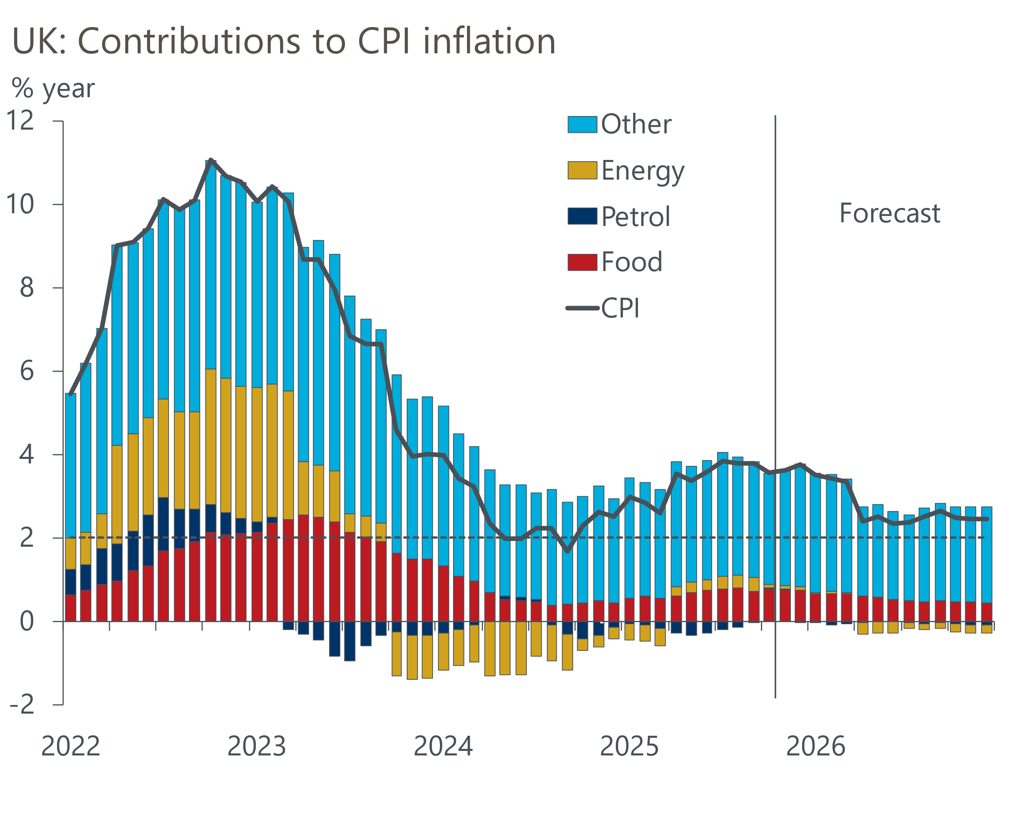
Sources: Oxford Economics, Haver Analytics
Furthermore, inflation pressures could be exacerbated by a renewed depreciation of sterling. Our baseline forecast shows sterling weakening next year. But we could see a steeper fall if markets lose faith in the government's fiscal approach. Given the UK is a relatively open economy, such a scenario could trigger a new wave of inflationary pressures.
The trajectory of services inflation, in particular, will be key to monetary policy decisions in 2026. The committee is deeply split on the outlook for inflation, with four members concerned that structural shifts in inflation expectations and price setting make it more likely that inflation will remain high. Four others are more worried about downside risks from weaker activity. Governor Andrew Bailey is currently the swing voter, but has hinted he thinks the risk profile is tilted to the downside.
The combination of weak activity and sticky inflation will continue to make it hard for the MPC to shift decisively in one direction or the other, which could lead to some volatility in short-end pricing. We think the MPC will loosen policy cautiously, cutting in either December or February and then implementing two more 25bp cuts in 2026. But if inflation proves stickier, we could see a prolonged pause from the MPC.

Theme 4: Another year of pain for the labour market
The labour market remains a key source of uncertainty, particularly as data quality is still a major problem. Although the Office for National Statistics has made some progress in overhauling the Labour Force Survey, results are still volatile and hard to square with other evidence, while survey samples remain well down on pre-pandemic levels. So analysis of the labour market continues to be challenging.
Fiscal policy has been a key influence on labour market trends. Employment in roles paid below the median salary has fallen, reflecting the significant increase in costs associated with these roles because of the rise in employers' national insurance contributions and the national living wage. But at the other end of the spectrum, public sector job creation has remained very strong, partly reflecting the government's spending increase implemented when it came to power in summer 2024. However, growth in government spending should now start to slow, suggesting job creation will also cool (Chart 5).
Chart 5: The labour market must become less reliant on public sector job creation
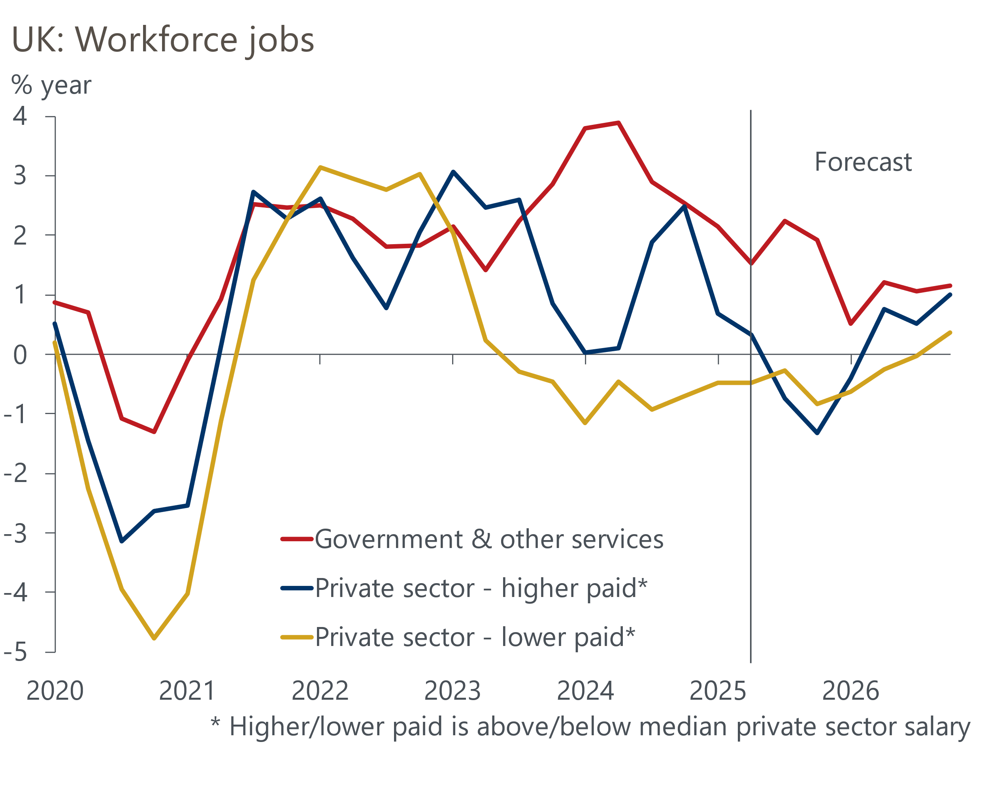
Sources: Oxford Economics, Haver Analytics
For the private sector, the outlook is mixed. On the one hand, future rises in labour costs are likely to be lower. So we think the recent fall in employment in lower-paid roles will prove to be a one-off adjustment to the build-up in cost pressures, rather than the start of a persistent decline in job numbers. But on the other hand, weak demand will weigh on private sector job creation. Our forecast shows the level of private sector employment lower at the end of 2026 than it was in early-2023.
This sectoral pattern should result in modest employment growth in 2026. But it's likely that jobs growth will be outstripped by improvements in labour supply, so we think unemployment will average a little over 5% in 2026.
That projection comes with a lot of uncertainties, however. This year's jump in labour costs was so large that it could prove to be a multi-year adjustment for some firms. The evolution of labour supply is also hard to pin down. Levels of inactivity remain much higher than they were before the pandemic, but the reasons for this phenomenon are still disputed. Meanwhile, the government has announced plans for further changes to immigration laws that are likely to make the UK a less attractive destination for legal migrants.
The evolution of inflation will be the most important influence on the MPC's thinking in 2026. But labour market developments will also figure prominently. Evidence of greater slack in the labour market and that it's weighing on pay growth will increase the scope for further monetary policy loosening next year.

